Assignment – 5

1. Create a form to enter name, email and phone no .so that when we enter any data it get appended to our existing data.

import React, { useState } from "react";

import { Button, Form } from "react-bootstrap";

import { useForm } from "react-hook-form";

export default function App() {

  const [details, setDetails] = useState([

    { name: "vasu", email: "vasu@gmail.com", phone: "9876543210" },

  ]);

  const {

    register,

    handleSubmit,

    formState: { errors },

  } = useForm();

  const onSubmit = (data) => {

    // console.log(data);

    setDetails((currentState) => [...currentState, { data }]);

    // console.log(details);

  };

  console.log(details);

  return (

    <Form className="divClass" onSubmit={handleSubmit(onSubmit)}>

      <Form.Group className="mb-3 pl-5 pr-5" controlId="formBasicEmail">

        <Form.Label>Name</Form.Label>

        <Form.Control

          type="text"

          placeholder="Enter your name"

          {...register("name", {

            required: true,

          })}

        />

        {errors.name && <p>name is required.</p>}

      </Form.Group>

      <Form.Group className="mb-3 pl-5 pr-5" controlId="formBasicEmail">

        <Form.Label>Email address</Form.Label>

        <Form.Control

          type="email"

          placeholder="Enter email"

          {...register("mail", {

            required: true,

          })}

        />

        <Form.Text className="text-muted">

          We'll never share your email with anyone else.

        </Form.Text>

        {errors.mail && <p>invalid E-mail please provide a valid Email</p>}

      </Form.Group>

      <Form.Group className="mb-3 " controlId="formBasicPassword">

        <Form.Label>Phone Number</Form.Label>

        <Form.Control

          type="text"

          name="phone"

          placeholder="enter Phone number"

          {...register("phone", {

            required: true,

          })}

        />

        {errors.phone && <p>phone number should have 10 digits</p>}

      </Form.Group>

      <Button variant="primary" type="submit">

        Register

      </Button>

    </Form>

  );

}

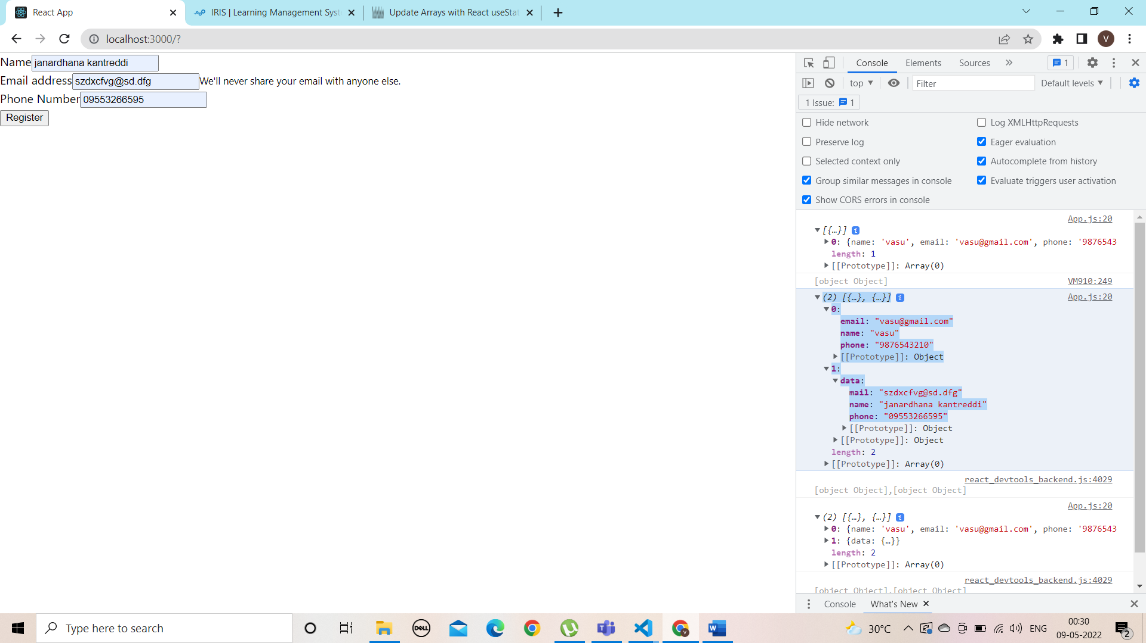

1. Using onChange() make the state change .It should display the details of the person like name, email and phoneno
2. import React, { useState } from "react";
3. export default function App() {
4. const [name, setName] = useState("");
5. const [email, setEmail] = useState("");
6. const [phone, setPhone] = useState("");
7. function handleChangeName(event) {
8. setName(event.target.value);
9. console.log(event.target.value);
10. }
11. function handleChangeMail(event) {
12. setEmail(event.target.value);
13. console.log(event.target.value);
14. }
15. function handleChangePhone(event) {
16. setPhone(event.target.value);
17. console.log(event.target.value);
18. }
19. return (
20. <>
21. name:
22. <input type="text" name="name" onChange={handleChangeName} value={name} />
23. email:
24. <input
25. type="email"
26. name="email"
27. onChange={handleChangeMail}
28. value={email}
29. />
30. phone no:
31. <input
32. type="phone"
33. name="phone"
34. onChange={handleChangePhone}
35. value={phone}
36. />
37. </>
38. );
39. }

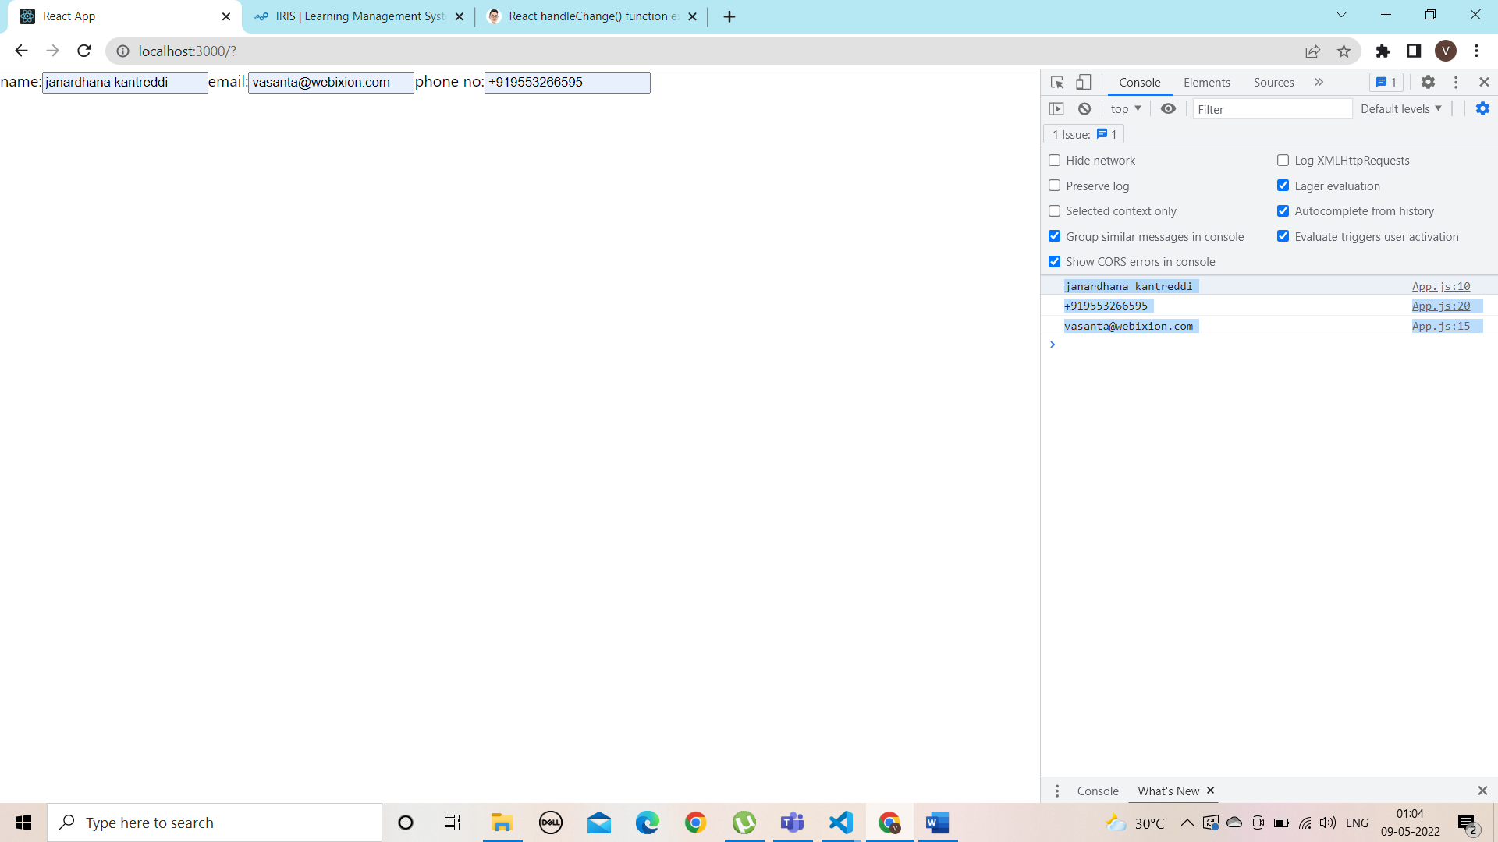

3. Create a react application by using static default Props and set the person details and display the details using this.props

import React, { Component } from "react";

export default class ThemedButton extends Component {

  // render() method

  render() {

    const { name, email, phone, ...props } = this.props;

    return (

      <>

        <h1>person details are:</h1>

        <h3 {...props}>{name}</h3>

        <h3>{email}</h3>

        <h3>{phone}</h3>

      </>

    );

  }

  static defaultProps = {

    name: "xyz",

    email: "xyz@gmail.com",

    phone: "1234567890",

  };

}

